PRIORITY SCHEDULING
#include <stdio.h>

int main()
{
int bt[20], p[20], wt[20], tat[20], pri[20];
int i, j, k, n, total = 0, temp;
float avg_wt, avg_tat;

printf("Enter number of processes: ");
scanf("%d", &n);

printf("\nEnter Burst Time for each process:\n");
for (i = 0; i < n; i++)
{
printf("P%d: ", i + 1);
scanf("%d", &bt[i]);
p[i] = i + 1; // process number
}

printf("\nEnter Priority for each process:\n");
for (i = 0; i < n; i++)
{
printf("P%d: ", i + 1);
scanf("%d", &pri[i]);
}

// Sorting processes based on priority (lower value = higher priority)
for (i = 0; i < n; i++)
{
for (k = i + 1; k < n; k++)
{
if (pri[i] > pri[k])
{
temp = p[i];
p[i] = p[k];
p[k] = temp;

temp = bt[i];
bt[i] = bt[k];
bt[k] = temp;

temp = pri[i];
pri[i] = pri[k];
pri[k] = temp;
}
}
}

wt[0] = 0; // Waiting time for first process is 0

// Calculate waiting time
for (i = 1; i < n; i++)
{
wt[i] = 0;
for (j = 0; j < i; j++)
wt[i] += bt[j];
total += wt[i];
}

avg_wt = (float)total / n; // Average waiting time
total = 0;

printf("\nProcess\tBurst Time\tPriority\tWaiting Time\tTurnaround Time");
for (i = 0; i < n; i++)
{
tat[i] = bt[i] + wt[i]; // Calculate turnaround time
total += tat[i];
printf("\nP%d\t\t%d\t\t%d\t\t%d\t\t%d", p[i], bt[i], pri[i], wt[i], tat[i]);
}

avg_tat = (float)total / n; // Average turnaround time

printf("\n\nAverage Waiting Time = %.2f", avg_wt);
printf("\nAverage Turnaround Time = %.2f\n", avg_tat);

return 0;
}

OUTPUT 1:
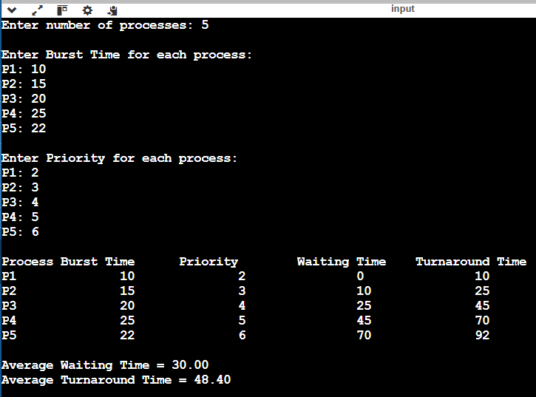

OUTPUT 2:

